Isoetes: Structure and Reproduction
Article Shared by <="">
ADVERTISEMENTS:
In this article we will discuss about the structure and reproduction in Isoetes with the help of diagrams.

Structure of Isoetes:
Sporophyte:
The plant resembles a monocot garlic plant in particular (Fig. 7.59). Isoetes is commonly called ‘Quill wort’ due to the quill (a large feather)-like structure of the leaves.
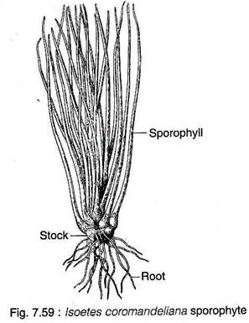
The plant body consists of a condensed, lobed corm or axis that bears a tuft of roots at the base and long feathery leaves on the top.
1. Corm or Axis:
The corm or axis is a condensed structure whose morphological nature is debatable. It has been interpreted as an erect rhizome, stock, corm or stem. The upper erect portion is actually the stem axis which gives rise to leaf traces.
The lower horizontal part is called rhizomorph which bears root traces. The axis is covered with dried leaf bases and roots of the previous year. The lower part of the axis is divided by a broad basal groove into 2-3 or rarely 4 lobes. The roots develop in definite rows radiating across each lobe (Fig. 7.60). The younger roots are borne nearer the groove, while the older ones are away from it.
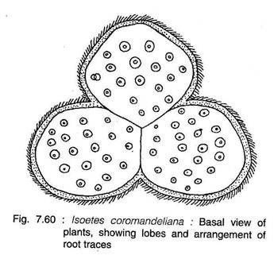
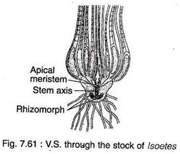
The apical meristem is covered by spirally arranged leaves and can only be seen after pulling out all the leaves (Fig. 7.61).
The 3-dimensional view of stele indicates that the stele is anchor-shaped and is differentiated into the upper cylindrical stem axis and the lower rhizomorph part which is extended horizontally with upturned lobes (Figs. 7.61 and 7.62).
The plants with trilobed basal part show four radiating arms in the T.S. of the lower part of stele. Because, one pair of arms diverges widely, while the other two arms come closer to give a trilobed appearance. In rare instances, all the four arms diverge widely to give four-lobed basal part (Fig. 7.63B).
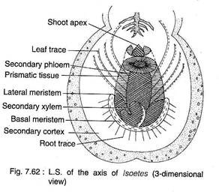
The T.S. and L.S. of the upper and the lower parts of the axis shows protostele where xylem is in centre, encircled by phloem that is not delimited from the adjoining cortex due to the absence of endodermis (Fig. 7.63A-C). In mature stem and rtiizomorph, a cambium is formed outside the phloem. The xylem is made up of reticulate and spiral tracheids intermixed with parenchyma.
The phloem consists of sieve tubes with sieve plates on the wall. The cortex is made up of starch-filled parenchyma with large intercellular spaces.
The secondary growth is noted in Isoetes. The activity of cambium is bifacial. It produces secondary cortex centrifugally (on the outside). As a result the secondary cortex pushes the primary cortex towards outside and it sloughs off every year as dead tissue.
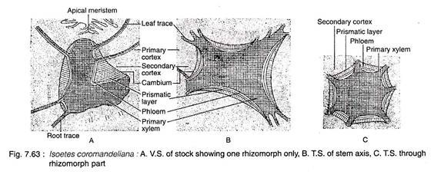
The cambium produces centripetally (towards Inside) secondary xylem of reticulate tracheids, or secondary phloem or a mixture of secondary xylem, secondary phloem and secondary parenchyma. Due to the inconstant nature of their centripetal secondary tissue, it has been described as ‘prismatic layer’ (Fig. 7.63A).
ADVERTISEMENTS:
Thus, the cambium is abnormal in position (develops outside the phloem) and also abnormal in function (produces secondary cortex outside and secondary phloem inside).
Some authors suggested that the cambium is comprised of two parts: a lateral meristem around erect axis, and a basal meristem around basal part. However, Bierhorst (1971) distinguished the basal meristem along the base of anchor-shaped stele from where only roots develop (Fig. 7.62).
2. Leaf:
The leaves are quill-like, develop from the apical meristem. The leaves are borne in acropetal order overlapping one another in a close spiral phyllotaxy. The leaves are micro- phyllous, ligulate, sessile with expanded base and an abruptly tapering apex.
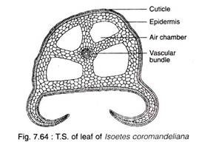
In Isoetes all the leaves are potentially fertile, thus leaves are called sporophylls. Each leaf is characterised by having a triangular cordate and colourless ligule on adaxial surface, and a small flap-like velum in-between sporangium and ligule (Fig. 7.66A).
Isoetes is heterosporous, thus micro- and megasporophylls are either distributed irregularly on the axis or mega- and micro- sporophylls are arranged successively from periphery to centre.
T.S. of the leaf of Isoetes shows a quadrangular outline with two expanded lateral wings on the lower side (Fig. 7.64). The epidermis is single-layered covered by a thin cuticular layer. There are four longitudinal air chambers running along the whole length of the leaf, separated from each other by transverse diaphragm.
There is a single collateral vascular bundle surrounded by undifferentiated mesophyll. In the basal part, the vascular bundle may be flanked on either side by two mucilage canals. These canals are comparable with the parichnos of the Lepidodendrales.
3. Root:
Numerous adventitious roots are developed from the basal part of the stele. The roots are dichotomously branched, bearing numerous root hairs. T.S. of the root of Isoetes shows a single- layered epidermis, followed by 4-8 layered parenchymatous cortex.
There is a central cavity and a single monarch vascular bundle is attached to the inner margin of cortex on one side of the cavity (Fig. 7.65). This reminds the Stigmarian rootlets of Lepidodendrales.
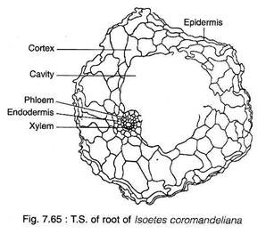

Reproduction in Isoetes:
The sporophyte of Isoetes reproduces mainly by spores. In rare instances, Isoetes propagates vegetatively by buds developing on the stem.
Sporangia:
Isoetes is a heterosporous lycopod, hence it produces both the microspore and megasppre. Both the spores are produced in separate sporangia, microspores in microsporangia and megaspores in megasporangia.
Hence there are two types of sporophylls: microsporophyll-bearing microsporangia and megasporophyll-bearing megasporangia (Fig. 7.66B, C). A single Isoetes plant bears both the sporophylls. The plant produces megasporangia first, followed by microsporangia and, finally, abortive sporangia.
The sporangia of Isoetes are the largest among the all known extant spore-producing plants. Isoetes also shows highest spore output, about 50 to 300 megaspores per megasporangium and about 150,000 to 1,000,000 microspores per microsporangium. Internally, the sporangium is partially or completely divided by plate-like trabeculae (Fig. 7.66B, C).
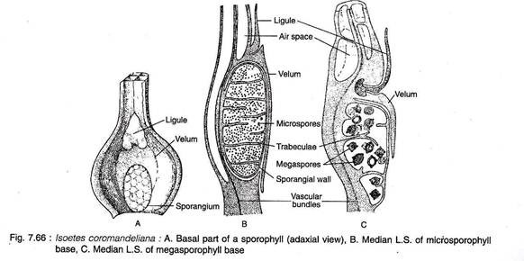
Development of Sporangium:
The development of both the micro- and megasporangia are similar up to the spore mother cell. The sporangia are of eusporangiate type. A group of sporangial initials divides periclinally to form outer jacket initial and an inner archesporial cell. The jacket initials, by anticlinal and periclinal divisions, produce 2-3- layered jacket of the sporangium.
The archesporial cells divide in all possible planes to produce a mass of sporogenous tissue which differentiates into spore mother cells. At the time of the formation of spore mother cells, some of the sporogenous tissues differentiate into trabeculae.
Some sporogenous tissue bordering the trabeculae and to the sides of sporangium differentiates into a two-layered tapetum. Microsporangia and megasporangia can only be distinguished at the time of sporocyte formation. In microsporangia the sporocytes differentiate after the formation of trabeculae, while in megasporangia the sporocytes differentiate before the formation of trabeculae.
In microsporangia, all the sporogenous cells differentiate and form microspores, whereas in megasporangia most of the sporogenous cells degenerate and only a limited number of surviving sporogenous cells differentiate to produce a limited number of megaspores.
The special mechanism for dehiscence of sporangia is absent, hence spores are released only after the death and decay of the sporangia.
Gametophytes:
The microspores and megaspores germinate endosporically to produce male and female gametophytes, respectively.
Male Gametophyte:
Microspores are small (30-40 µm in diam.), triangular with trilete apertures.
Microspores germinate immediately after falling upon a suitable substratum, thus a male gametophyte is formed within a few days (Fig. 7.67A-1).
The first division (1-1) of microspore is asymmetric to give rise to a small prothallial cell and a large antheridial initial. The prothallial cell does not divide, it is adpressed to the base of the spore. The antheridial initial divides (2-2) diagonally to produce two cells, of these the cell close to the prothallial cell becomes the first jacket cell, while the other cell further divides (3-3) at right angle to the previous division.
Out of these two cells thus formed, the cell farthest from the prothallial cell becomes the second jacket cell, whereas the other cell again divides (4-4) in a plane almost parallel to the preceding plane of division to produce two cells. Of the two cells thus formed, the outer cell forms the third jacket cell and the inner one divides (5-5) periclinally to form a fourth jacket cell and a central primary androgonial cell.
The primary androgonial cell by two successive divisions at right angles to each other, forms four androcytes. Thus a mature male gametophyte consists of nine cells : one prothallial cell, four jacket cells and 4 androcytes. Each androcyte metamorphoses into a corkscrew-shaped, multiflagellated (about 15 flagella) antherozoid with a terminal vesicle (Fig. 7.67J).
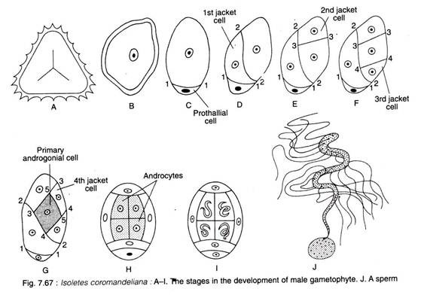
The antherozoids are liberated through the expansion of trilete aperture.
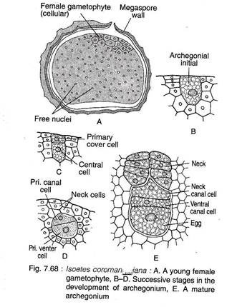
Female Gametophyte:
The megaspores are comparatively larger (250-900 µm in diameter) than microspores. They are triangular in shape with trilete aperture. The exine is provided with large spinulate projections.
On germination, megaspore begins with a series of free nuclear divisions (Fig. 7.68A). About 30-50 nuclei thus formed are dispersed towards the periphery. However, there is no central vacuole as in Selaginella. Later, wall formation starts from the apical part and slowly extends downwards (Fig. 7.68A). The wall formation continues even after the formation of new sporophyte.
The megaspore wall breaks open along the trilete aperture to expose the apicaI cellular gametophytic tissue. Generally two to three archegonia develop on this apical exposed tissue. The nature of development of archegonium from the archegonial initial is like that of Selaginella (Fig. 7.68B-D).
A mature archegonium has a neck comprised of four vertical rows of neck cells (4 cells in each row), one neck canal cell, one ventral canal cell and an egg (Fig. 7.68E).
Fertilisation:
Like other pteridophytes, fertilisation takes place as usual.
The New Sporophyte (Embryo):
The zygote first divides by an oblique wall, followed by a vertical wall, thus four cells are formed in two tiers (Fig. 7.69A, B). All the cells contributes to the formation of embryo. Unlike other lycopsids, there is no suspensor in Isoetes embryo. The foot is formed from the two hypobasal cells.
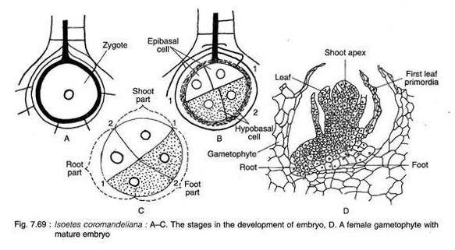
Out of the two epibasal cells, one contributes to the formation of cotyledon, while root is formed from the other cell. The developmental pattern of embryo is of endoscopic type.
Gradually the embryo becomes cylindrical and subsequent development continues in one direction upturning the embryo (Fig. 7.69C). As a result, the upper foot region is now shifted to the basal region. The stem apex differentiates at a later stage (Fig. 7.69D).
Fig. 7.70 shows the life cycle of Isoetes.
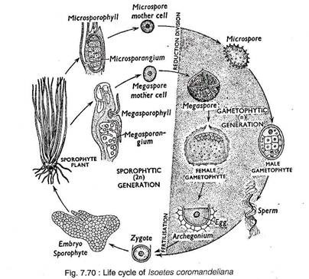

Related Articles:

